Github for beginners

Download git and then open git bash in your local machine/desktop/laptop

First you need to configure your username and email in git bash:-

git config --global user.name “**your_github_username**”

git config --global user.email “**your_github_email_Id**”

**How to share/push/upload data from local system to repository**

The data which we want to push to our repository is in the d directory with name git_test

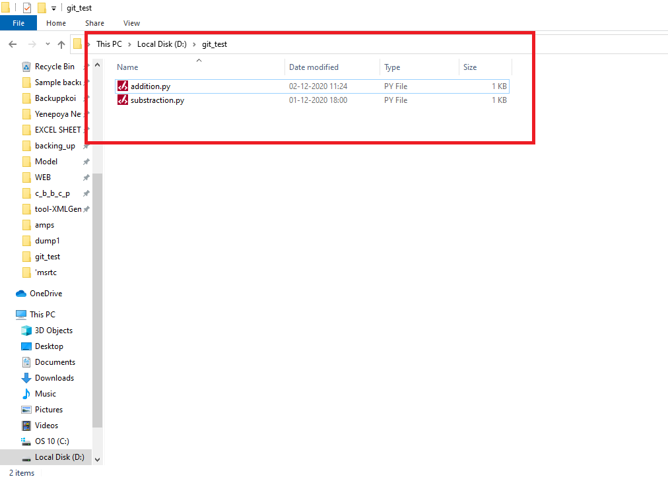

Open git bash on your local system and enter the directory on your local machine that you want to push using command:

**>> cd d:**

**>> cd git_test**

Now you will be in git_test directory

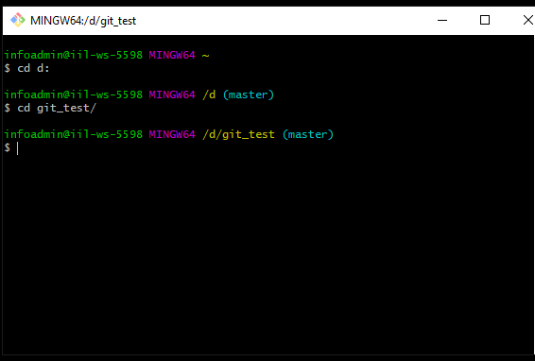

After doing above steps only start the Steps involved procedure

**Git architecture**

addition.py

addition.py

Substraction.py

Substraction.py

File 1

Local system

github Repository

git push

git add addition.py

git add substaction.py

addition.py

addition.py

Substraction.py

Substraction.py

git commit –m “message”

Local version control database

It’s on your local system only

Staging area

In Local system we have two files addition.py and substraction.py .

Staging area :- **Staging area** is files that are going to be a part of the next commit, which lets **git** know what changes in the file are going to occur for the next commit.

Here once you use the **add** command this will store your data to an staging area and when you will use the **commit** command then it will store your changes to the local version control database that will be on your local system only.

**Steps involved:**

**Step 1:- Initialise git**

You need to initialise git in the directory that is in your local system:-

Type command :

**>> git init**

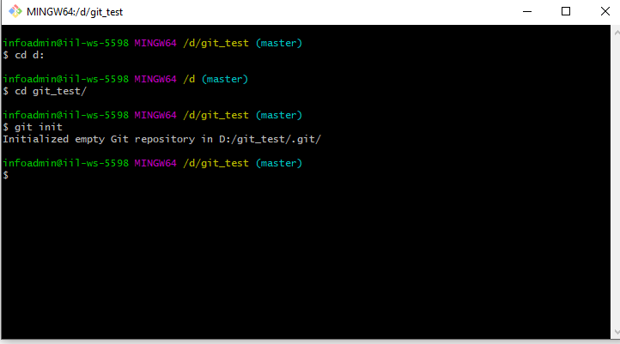

Now your local system directory is initialised and it will create a directory named **.git**

**.git🡪** The . **git** folder contains all the information that is necessary for your project in version control and all the information about commits, remote repository address, etc. All of them are present in this folder.

As below you can see that now our folder git_test has a new folder named .git.

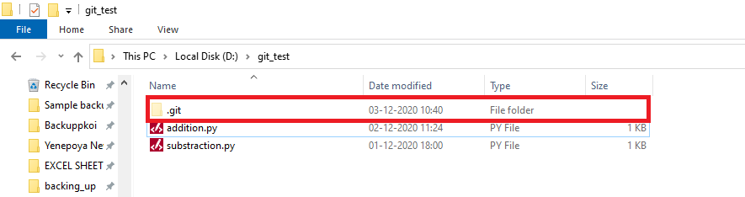

**Step 2: add your files**

Now we will add our files to staging area using the command **add.**

**>> git add file_name**

**>>git add addition.py**

**>> git add substraction.py**

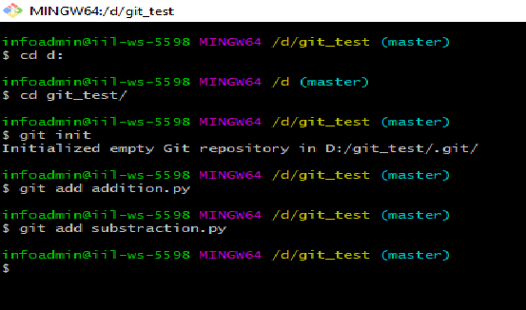

**Note:**

**>>git add . 🡪we use dot to add all files in single step**

**I have added two files to staging are that is:**

**1-addition.py**

**2-substraction.py**

**Step 3: Commit**

Once files are added to staging area we need to commit

Once the file will be added to the staging area we will use the commit command to save the changes with a message for the commit.

In order words the "**commit**" command is used to save your changes to the local repository.

After commit we have to push our data to remote repository so for that we need to add remote repository

**Adding remote repositories:**

**Command:**

**git remote add <name> <url of your repository>**

Here **name** is short name you can give while adding the repository this is a short name given to the repository so later it will be easy to push the data using the shortname.

git remote add python <https://askd>..............

**Check remote repositories added**

git remote

git remote –v

Once all the above steps are done now it’s time to push the code to your repository

**Step 4: Push**

**git push <url><branch>**

Instead of URL you can use the short name as discussed above

**Git branch**

How to create a new branch we should run the command :

**git branch branch _name**

After creating the new branch we need to switch to that branch:

**git checkout branch_name**

If we want to create a new branch and switch to it as well we will use a command:

**git checkout –b new_branch_name**

**How to switch to another branch in git:**

To switch to another branch we use command:

**git checkout branch_name**

To delete a git branch we use command:

**git branch –delete branch_name**